# BMSN1601 – Anatomy – Part II – Part B (L16~L17)

|  |
| --- |
| Introduction to the Respiration Process |

* Respiration involves **4 distinct** processes

|  |  |  |  |
| --- | --- | --- | --- |
| Pulmonary ventilation | External respiration | Transport | Internal respiration |
| movement of air  into & out of lungs | Gas exchange between lungs & blood | transport of O2 & CO2 between lungs & tissues | gas exchange between systemic blood vessels & body tissues |

* Recap: Basic Information About Different Pressure during the discussion
  + Atmospheric pressure: 760mmHg
  + Intrapulmonary Pressure [Palv]: Pressure in the alveolar
  + – Intrapleural Pressure [Pip] = Collapsing Pressure of Lung  
    → The Intrapleural Pressure is always smaller than Intrapulmonary Pressure
* Recap: Basic Information About Inspiration
  + Lungs are stretched & intrapulmonary volume increases  
    → Intrapulmonary pressure drops (-1 mmHg / Minimum Value)  
    → Air flows into lungs down pressure gradient  
    → Intrapulmonary Pressure gradually increase → Intrapulmonary Pressure = Atmospheric Pressure (760mmHg)

|  |  |
| --- | --- |
| 💬 | **Lungs can slide but not separated from pleura**   * Lungs adhere to thoracic wall * Expand/recoil as thoracic cavity changes in volume during breathing |

* Recap: Basic Information About Expiration
  + Quiet expiration depends on natural elasticity of lungs  
    → No Muscle Contraction
  + **Inspiratory muscles relax** & **resume resting length**  
    → Rib cage descends due to gravity  
    → Volume of thoracic cavity decreases  
    → Lungs **recoil**
  + Intrapulmonary volumes decreases  
    → Intrapulmonary pressure rises (to +1 mm Hg / Maximum Value)
* Pressure & Volume Changes during Pulmonary ventilation

|  |  |  |
| --- | --- | --- |
|  | Intrapulmonary pressure  (Relative) | Intrapleural pressure  (Relative) |
| Inspiration | -1mmHg | -6mmHg |
| Expiration | +1mmHg | -3mmHg  Still **(< intrapulmonary pressure**) to **keep alveoli inflated** |

|  |
| --- |
| Introduction to the Clinical Physiology Regarding the Pulmonary Ventilation |

* Dead Space: Volume of inhaled air which **does not take part in gas exchange**

|  |  |
| --- | --- |
| Dead Space | |
| Anatomical Dead Space | Volume of conducting respiratory passageways (~150mL) |
| Alveolar dead spaces | Volume occupied by alveoli that stop to act in gas exchange (**due to collapse, obstruction or lack of adjacent pulmonary capillaries**)   * Emphysema * Pneumonia * Chronic obstructive pulmonary disease |

* Non-respiratory Air Movements
  + Coughing, Sneezing, Crying, Laughing, Yawning

|  |
| --- |
| Introduction to the Lung Volume & Lung Capacities |

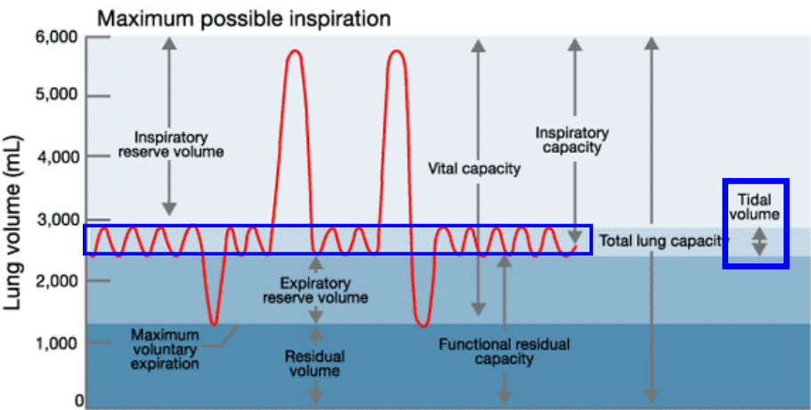

|  |  |
| --- | --- |
| Tidal volume (TV) | * volume of air that moves into or out of lungs with **each normal, quiet breath**   (~ 500 mL) |
| Inspiratory reserve volume (IRV) | * extra volume of air that can be inspired forcibly **after a tidal inspiration**   (2,100 – 3,200 mL) |
| Expiratory reserve volume (ERV) | * extra volume of air that can be evacuated from lungs **after a tidal expiration**   (1,000 – 1,200 mL) |
| Residual volume (RV) | * volume of air left in lungs **after strenuous expiration**   (1,200 mL) |

|  |  |
| --- | --- |
| Inspiratory capacity (IC) [**total amount of air that can be inspired after a tidal expiration**] | Tidal volume (TV) |
| Inspiratory reserve volume (IRV) |

|  |  |
| --- | --- |
| Functional residual capacity (FRC)  [~~total~~ **amount of air remaining in lungs after a tidal expiration**] | Expiratory reserve volume (ERV) |
| Residual volume (RV) |

|  |  |
| --- | --- |
| Vital capacity (VC)  [**total amount of exchangeable air (TV + IRV + ERV)**] | Tidal volume (TV) |
| Inspiratory reserve volume (IRV) |
| Expiratory reserve volume (ERV) |

|  |  |
| --- | --- |
| Total lung capacity (TLC) | Tidal volume (TV) |
| Inspiratory reserve volume (IRV) |
| Expiratory reserve volume (ERV) |
| Residual volume (RV) |